## MINI PROJECT II

**(2020-21)**

**FULLSTACK WEBSITE**

**MID-TERM REPORT**



**Institute of Engineering & Technology**

**Submitted by-**

**Nikhil Baghel (181500424)**

***Supervised By: -***

## Mr. Amir Khan

## Department of Computer Engineering & Applications

**Contents**

Abstract 3

1. Introduction 4
   1. General Introduction to the topic **4**
   2. Technology Used **5**
   3. Hardware and Software Requirements **8**
2. Objective 8
3. Implementation Details 9
4. Progress till Date & The Remaining work 17
5. Some Screenshots 18
6. References 27

## Abstract

In this project, we build a simple website that can be used by all where consumer buy goods and services without any intermediatory service over the internet. This website would be built using HTML, CSS, Bootstrap, JavaScript MySQL and PHP. As we know, HTML is used to structure a website, CSS (cascading style sheets) are used to styling a webpage.

## Introduction

# General Introduction to the topic

In this project, we build a simple e-commerce full stack website “Lifestyle Store”. An e-commerce website is an information technology method in which traders can sell products and the customer can purchase on that website electronically by using the internet on the mobile and computer. The technology used in this project are HTML (Hypertext Markup Language), CSS (cascading style sheets), JavaScript, Bootstrap, SQL (Structured Query Language) and PHP (Hypertext Pre-processor).

The website will contain the following pages:

1. Index Page

2. Sign up Page

3. Login Page

4. Cart Page

5. Setting Page

6. Logout Page

7. Success Page

8. Product Page

# Technology Used

1. **HTML**: **Hypertext Markup Language** (**HTML**) is the standard markup language for documents designed to be displayed in a web browser. It can be assisted by technologies such as Cascading Style Sheets (CSS) and scripting languages such as JavaScript.

Web browsers receive HTML documents from a web server or from local storage and render the documents into multimedia web pages. HTML describes the structure of a web page semantically and originally included cues for the appearance of the document.

HTML elements are the building blocks of HTML pages. With HTML constructs, images and other objects such as interactive forms may be embedded into the rendered page. HTML provides a means to create structured documents by denoting structural semantics for text such as headings, paragraphs, lists, links, quotes and other items. HTML elements are delineated by *tags*, written using angle brackets. Tags such as

<**img** /> and <**input** /> directly introduce content into the page. Other tags such as <**p**> surround and provide information about document text and may include other tags as sub-elements. Browsers do not display the HTML tags, but use them to interpret the content of the page.

HTML can embed programs written in a scripting language

1. **CSS: Stands for "Cascading Style Sheet."** Cascading style sheets are used to format the layout of Web pages. They can be used to define text styles, table sizes, and other aspects of Web pages that previously could only be defined in a page's HTML.

There are three types of CSS:

**External** style sheets are separate files full of CSS instructions (with the file extension .

css. When any web page includes an external stylesheet, its look and feel will be controlled by this CSS file (unless you decide to override a style using one of these next two types). This is how you change a whole website at once. And that's perfect if you want to keep up with the latest fashion in web pages without rewriting every page!

**Internal** styles are placed at the top of each web page document, before any of the content is listed. This is the next best thing to external, because they're easy to find, yet allow you to 'override' an external style sheet -- for that special page that wants to be a nonconformist!

**Inline** styles are placed right where you need them, next to the text or graphic you wish to decorate. You can insert inline styles anywhere in the middle of your HTML code, giving you real freedom to specify each web page element. On the other hand, this can make maintaining web pages a real chore!

1. **Bootstrap: Bootstrap** is a free and open source CSS framework directed at responsive, mobile first front end development. It contains CSS- and (optionally) JavaScript-based design templates for typography, forms, buttons, navigations, and other interface components. Bootstrap is the seventh-most-starred project on GitHub, with more than 142,000 stars, behind freeCodeCamp (almost 312,000 stars) and marginally behind Vue.js framework. According to Alexa rank, Bootstrap is in the top-2000 in the USA while vuejs.org is in the top-7000 in the USA. Bootstrap is a web framework that focuses on simplifying the development of informative web pages (as opposed to web apps). The primary purpose of adding it to a web project is to apply Bootstrap's choices of color, size, font and layout to that project. As such, the primary factor is whether the developers in charge find those choices to their liking. Once added to a project, Bootstrap provides basic style definitions for all HTML elements. The result is a uniform appearance for prose, tables and form elements across web browsers. In addition, developers can take advantage of CSS classes defined in Bootstrap to further customize the appearance of their contents. For example, Bootstrap has provisioned for light- and dark-colored tables, page headings, more prominent pull quotes, and text with a highlight.

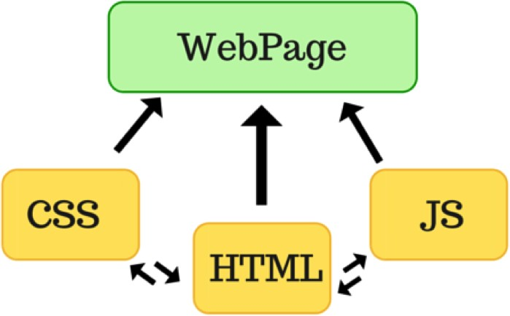

1. **JavaScript:** It is a scripting language used to create and control dynamic website content that is anything that moves, refreshes or otherwise changes on your screen without requiring you to manually reload a webpage features like
   * Animated graphics
   * Photo slideshows
   * Autocomplete text suggestions
   * Interactive forms

An even better way of understanding what javascript does is to think about certain web features you use every day and likely take for granted- like when your facebook timeline automatically updates on your screen or Google suggest terms based on a few letters you have started typing. Javascript is an integral part of Web functionality, all major Web Browsers come with built-in engines that can render javascript.

1. **PHP:** PHP code is usually processed on a web server by a PHP interpreter implemented as a module, a daemon or as a Common Gateway Interface (CGI) executable. On a web server, the result of the interpreted and executed PHP code – which may be any type of data, such as generated HTML or binary image data – would form the whole or part of a HTTP response. Various web template response, web content management systems, and web framework exists which can be employed to orchestrate or facilitate the generation of that response. Additionally, PHP can be used for many programming tasks outside of the web context, such as standalone graphical applications and robotic drone control.
2. **MySQL**: **MySQL** is an open source relational database management system (RDBMS). Its name is a combination of "My", the name of co-founder Michael Widenius’s daughter, and "SQL", the abbreviation for Structured Query Language. A relational database organizes data into one or more data tables in which data types may be related to each other; these relations help structure the data. SQL is a language use to create, modify and extract data from the relational database, as well as control user access to the database. In addition to relational databases and SQL, an RDBMS like MySQL works with an operating system to implement a relational database in a computer's storage system, manages users, allows for network access and facilitates testing database integrity and creation of backups. MySQL Database Service is a fully managed database service that enables organizations to deploy cloud-native applications using the world's most popular open source database. It is 100% developed, managed and supported by the MySQL Team

## Hardware and Software Requirements

#### Hardware

* Memory [4GB RAM (or higher)]
* Intel core i3 64-bit Processor (or higher)

#### Software

* + Window 7 or 8 or 10
  + Visual Studio code
  + Apache Server or XampServer
  + GitHub
  + Google chrome or Opera Browser

**Objective**

Online shopping is the process whereby consumers directly buy goods and services without any intermediatory services over the internet. The Objective of this website is to build a web-based website for purchasing music albums according to people’s interests.

## Implementation Details

**Web development** is the work involved in developing a web site for the Internet (World Wide Web) or and intranet (a private network). Web development can range from developing a simple single static page of plain text to complex Web-based Internet Applications (Web apps), electronic business, and social network services. A more comprehensive list of tasks to which Web development commonly refers, may include Web engineering, Web design, Web content development, client liaison, client side or server side scripting, Web server and network security configuration, and e-commerce development.

Among Web professionals, "Web development" usually refers to the main non-design aspects of building Web sites: writing markup and coding. Web development may use content management systems (CMS) to make content changes easier and available with basic technical skills.

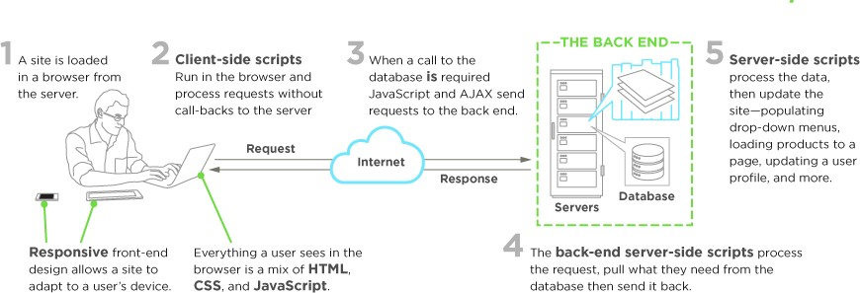

For larger organizations and businesses, Web development teams can consist of hundreds of people (Web developers) and follow standard methods like Agile methodologies while developing Web sites. Smaller organizations may only require a single permanent or contracting developer, or secondary assignment to related job positions such as a graphic designer or information systems technician. Web development may be a collaborative effort between departments rather than the domain of a designated department. There are three kinds of Web developer specialization: front-end developer, back-end developer, and full stack developer. Front-end developers are responsible for behaviour and visuals that run in the user browser, while back-end developers deal with the servers

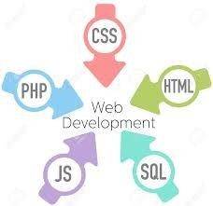

A **website** (also written as **web site**) is a collection of web pages and related content that is identified by a common domain name and published on at least one web server. Notable examples are google.com, yahoo.com etc. All publicly accessible websites collectively constitute the World Wide Web. There are also private websites that can only be accessed on a private network, such as a company's internal website for its employees.

Websites are typically dedicated to a particular topic or purpose, such as news, education, commerce, entertainment, or social networking. Hyperlinking between web pages guides the navigation of the site, which often starts with a home page. Users can access websites on a range of devices, including desktops, laptops, tablets and smart phones. The software application used on these devices is called a web browser. Websites can be used in various fashions: a personal website, a corporate website for a company, a government website, an organization website, etc

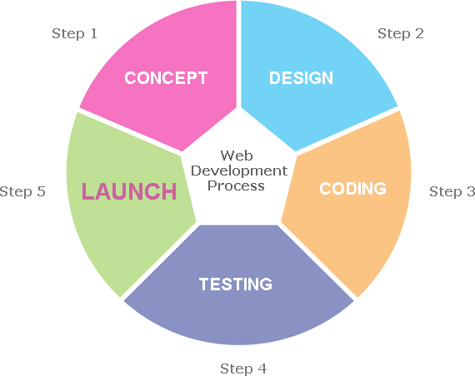

So far, we have completed our index page, signup page, login page, change password page, about us page. The technology we used in this project till now are HTML, CSS and Bootstrap, The platform used is Visual studio code( VS code).

1. **Index page:** The page divided into three sections header, container and footer. The header basically is navigation bar which has submenu about us, signup and login. We have used the concept of unordered list here.

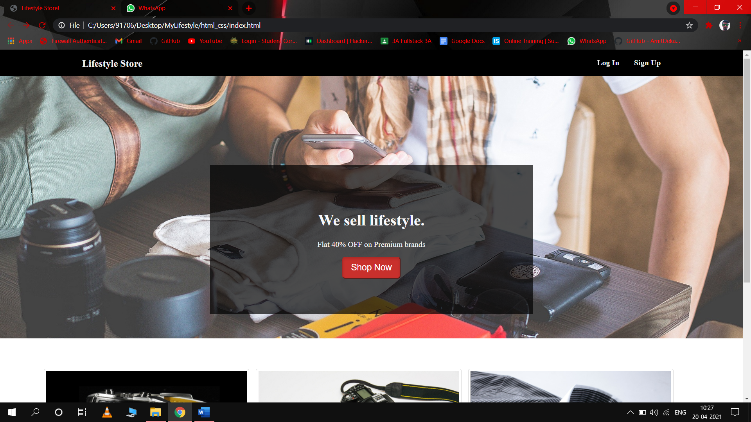

1. **Signup page:** this page is also dived into three section, header, container and footer. Header and footer section section are same as above bot footer section has different colour this time.

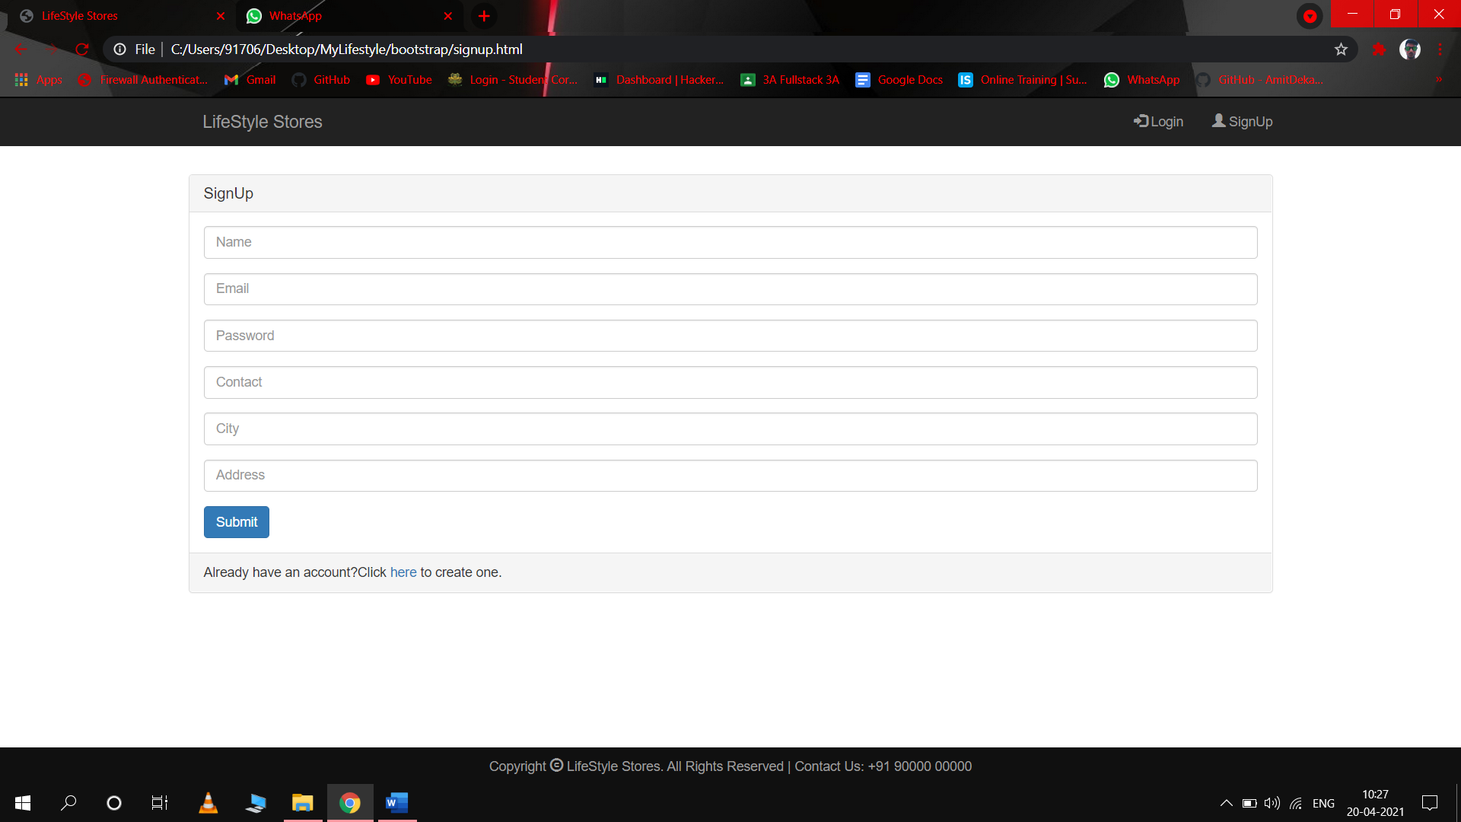

1. **Login page:** this page is also divided into three section header , footer and container .Header and footer are same as in signup page. The container section is different, it includes login form in centre and also include a image as a background.

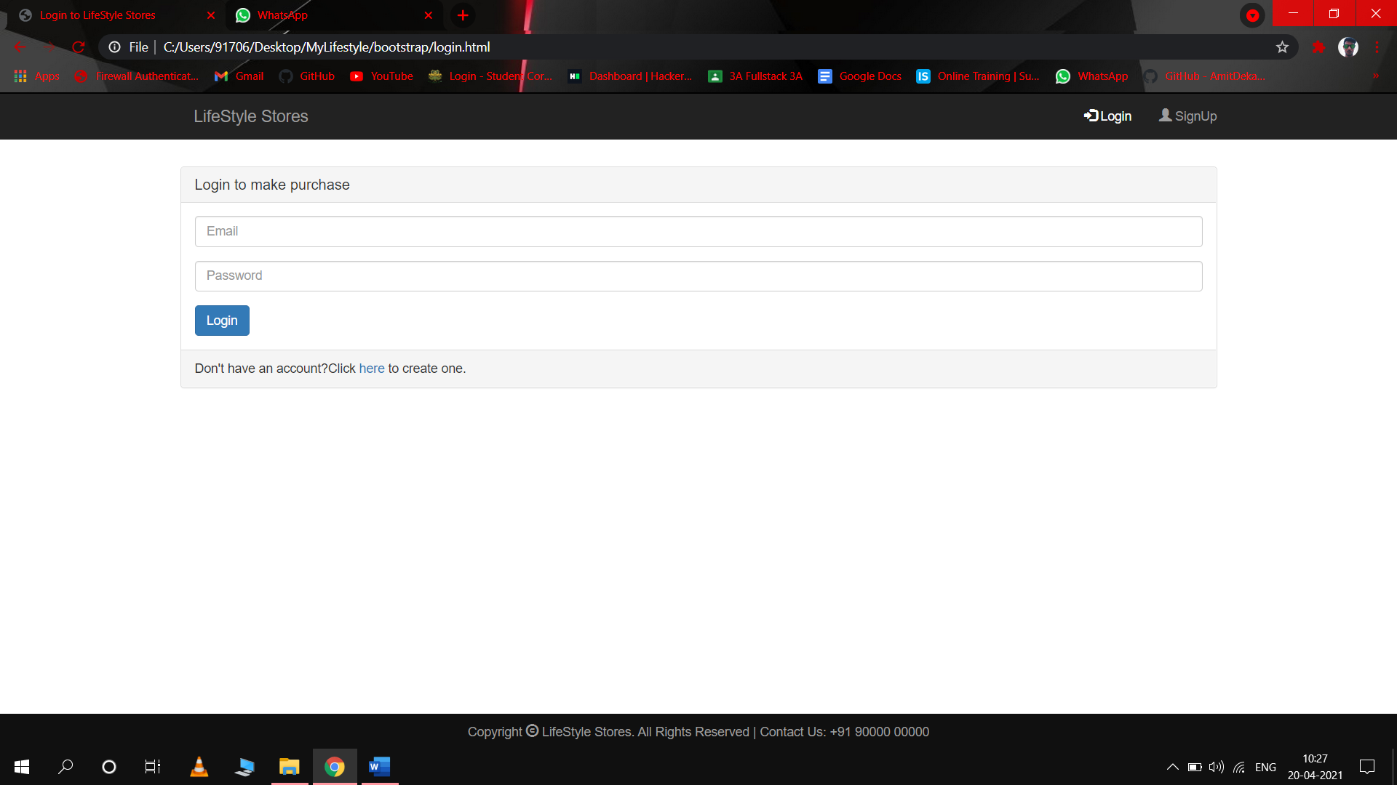

1. Logout page : a simple page implying that the user has done logout successfully.

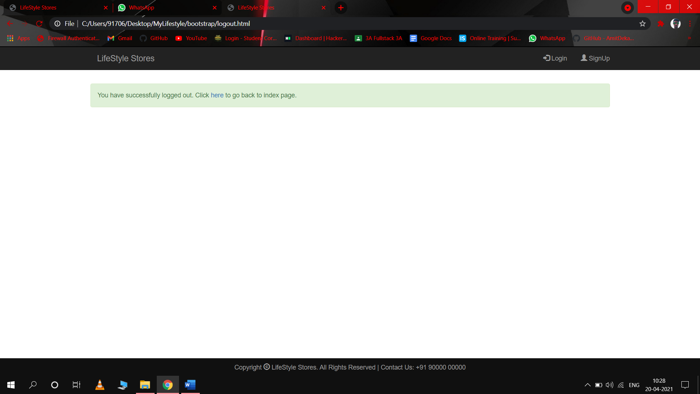

**Database:** we have also started **initial** work on database. We have created a table of User data in which name, email, phone number. and password are included and the phone number is taken as primary key of the table .

XampServer is used in this project for creating local server in this project. Later we will more work on our database and also use PHP for interacting between database and website.

## Progress till date & the remaining work

#### Progress till date:

Till now, out of 8 pages, 4 pages have been completed i.e.

* IndexPage
* Signup Page
* Login Page
* Logout Page

The technology used till now are HTML, CSS, Bootstrap.

#### Remaining Work:

Database have to be created , and a local server will be created with the help of XampServer. Some pages have to be created are given below:

* Cart Page
* Product page
* Setting page
* Success Page

The technology will be used PHP, Javascript, MySQL, HTML, CSS, Bootstrap.

**SOME SCREENSHOTS**



### 





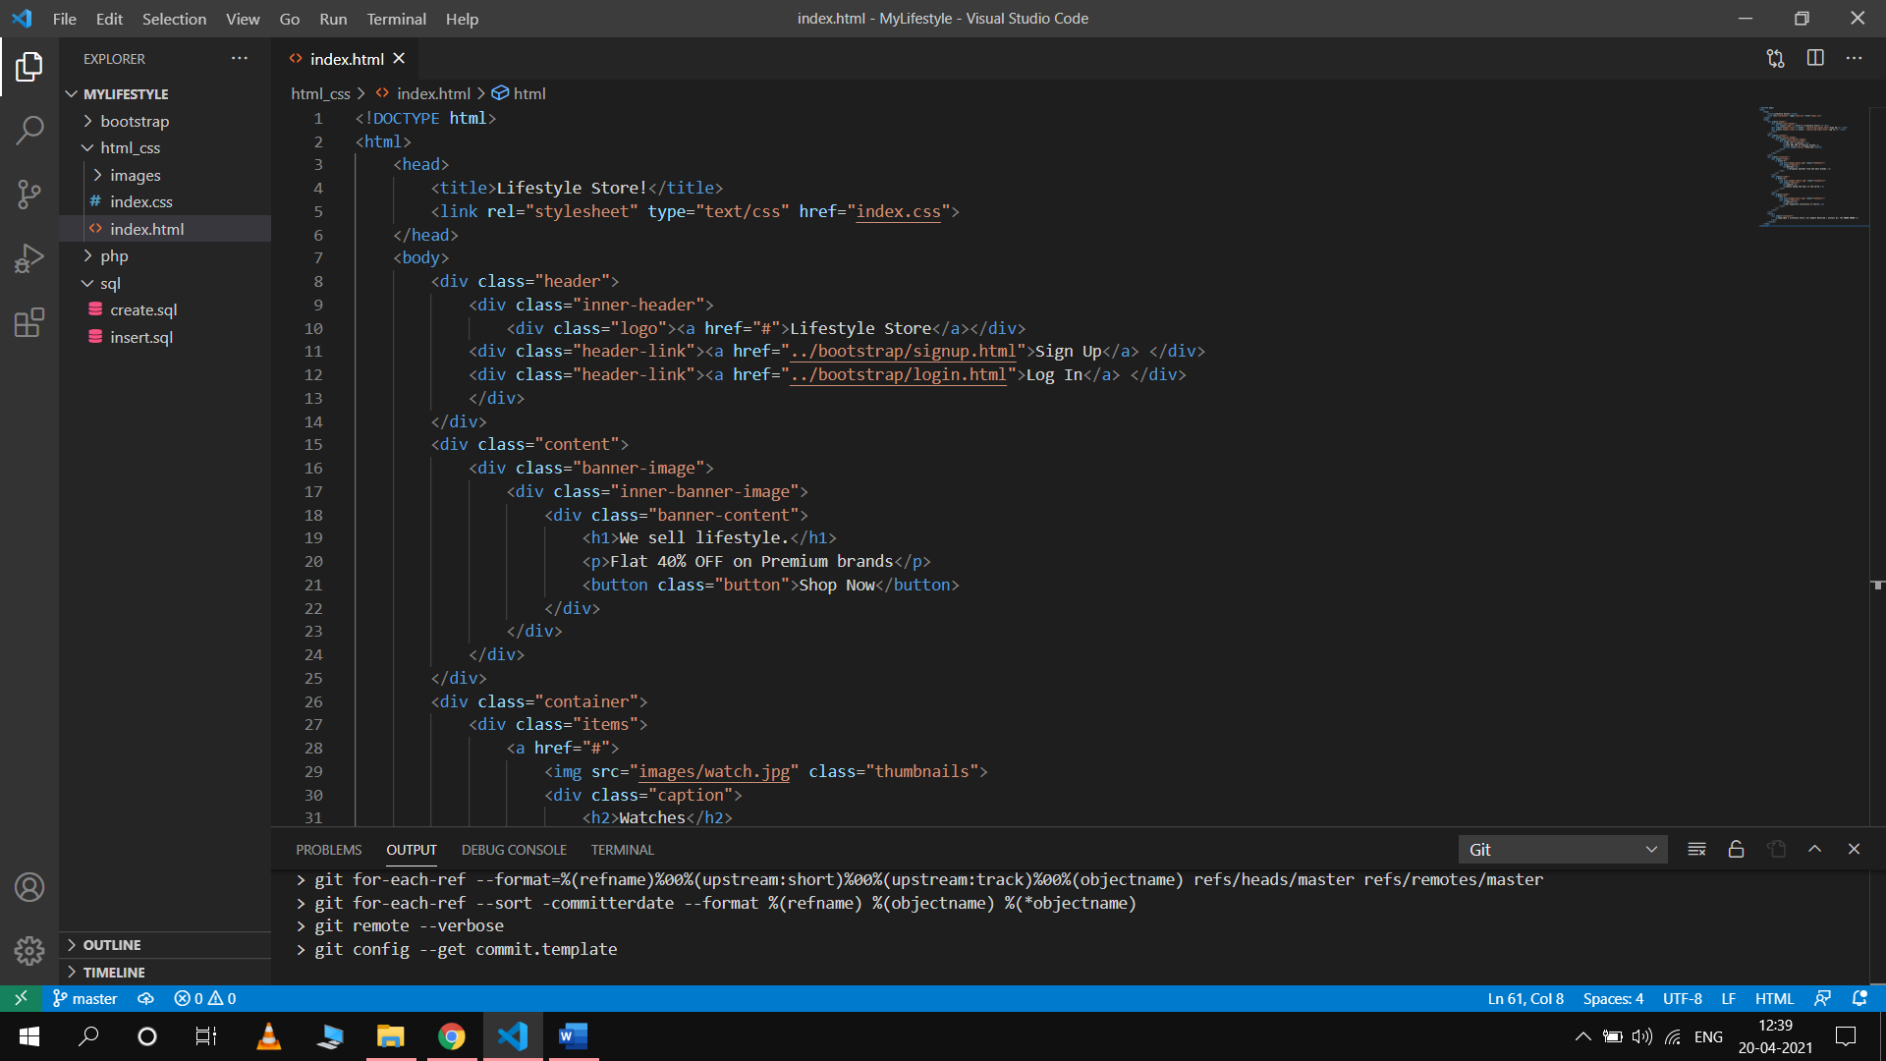

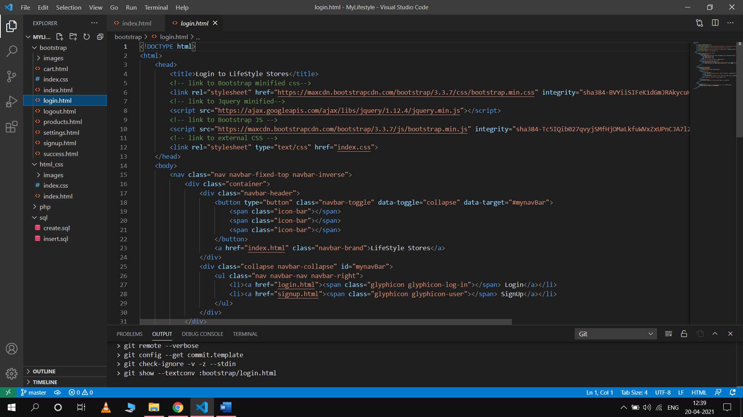

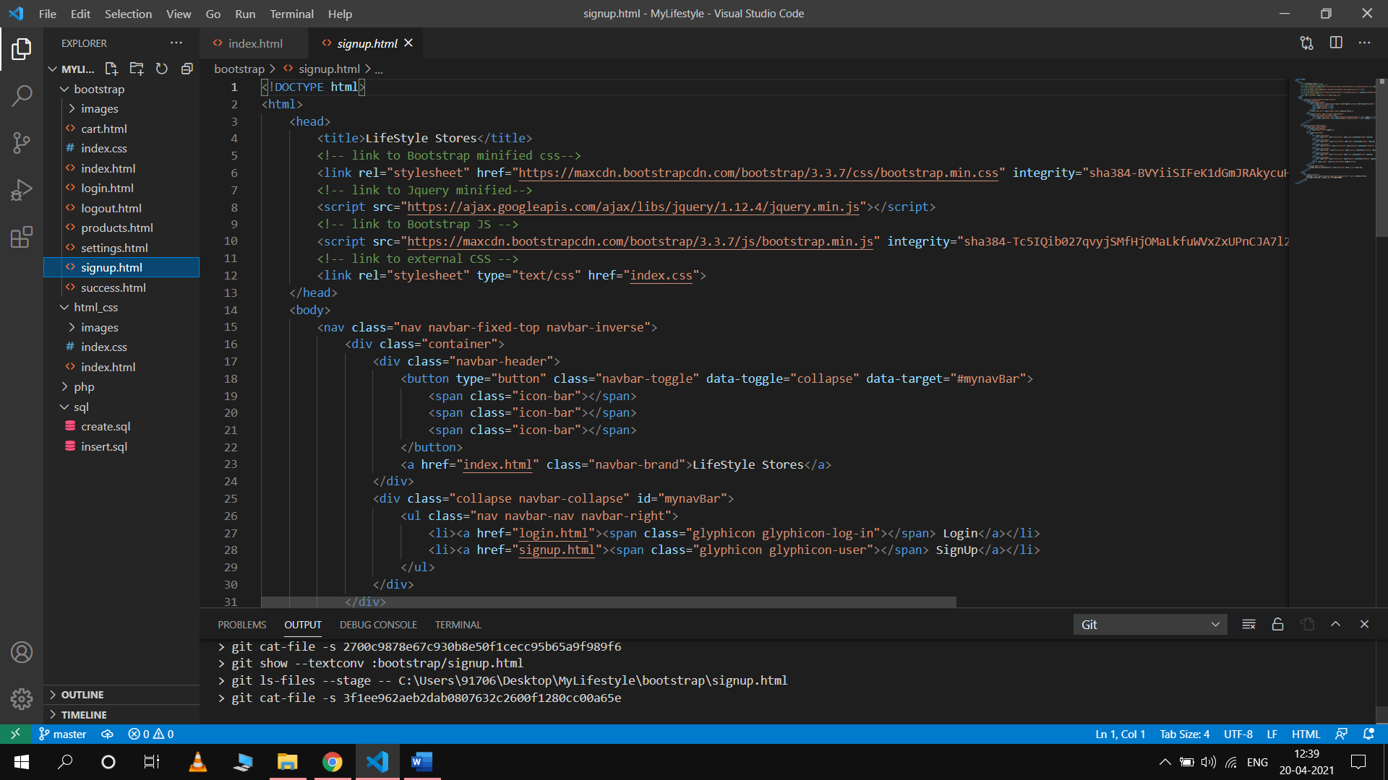

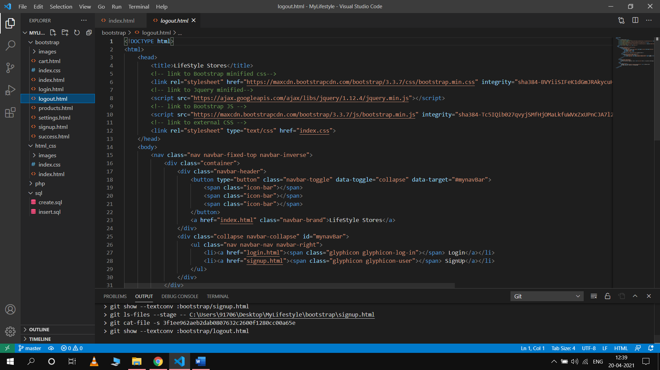

**References**

* <https://www.w3schools.com/html/>
* <https://www.w3schools.com/css/>
* <https://www.w3schools.com/php/>
* [https://fontawesome.com](https://fontawesome.com/)
* [https://getbootstrap.com](https://getbootstrap.com/)